CHAPTER 1

INTRODUCTION

Every day the world is becoming more and more digital, connected, and automated, but what makes this transformation possible? In many cases, it is a technology that is often overlooked: embedded systems. Embedded systems play a part in nearly every aspect of modern life. They impact the way we spend our leisure time, the way we commute, and the way we do business. Embedded systems are ideal for use in automated systems. The goal of automated systems is to increase the speed of manufacturing and other operations while reducing the risk of human error and increasing operator safety. Automation applications rely on embedded flash memory to execute processes . And One of the major aspects of this embedded systems are the automation Feature and it reduces time, effort and cost, whilst reducing manual errors, giving your business more time to focus on your primary objectives .

CHAPTER 2

2.1 Block Diagram

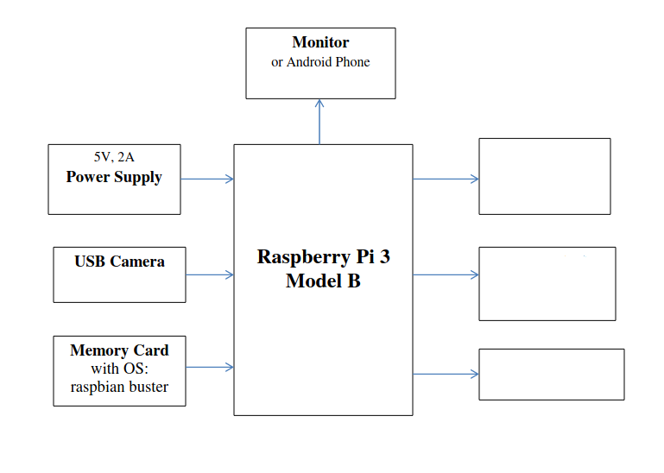

Stepper Motor
Voltage Controller
Circuit

Temprature Sensor
(MLX)
Figure 2.1 Block Diagram

2.2 Working
IOT BASED TEMPRATURE MASK SCAN ENTRY BARRIER first scans for mask in the face and after it detects mask it go for temprature scan if they bot ok then the barrior will undo . The is the sould concept of this project and for this to accomplish image procesing and realtime temprature scanning is used . The image processing is done by the help of Raspberry pie and using python 3.x , for this we use only Raspberry pie to monitor and control .
In image processing which is the process of transforming an image into a digital form and performing certain operations to get some useful information from it , the OpenCV which is an open source vision and machine learning software library, is used also

2.3 Components used
- Raspberry pie 3 Model B
- USB Webcam
- Stepper Motor
- Voltage Regulator
- Power Supply 12v
- Power Supply 5v

2.4 Software’s used
- Python IDE
- Real VNC Viewer

CHAPTER 3
HARDWARE DESCRIPTION
3.1 Raspberry Pi
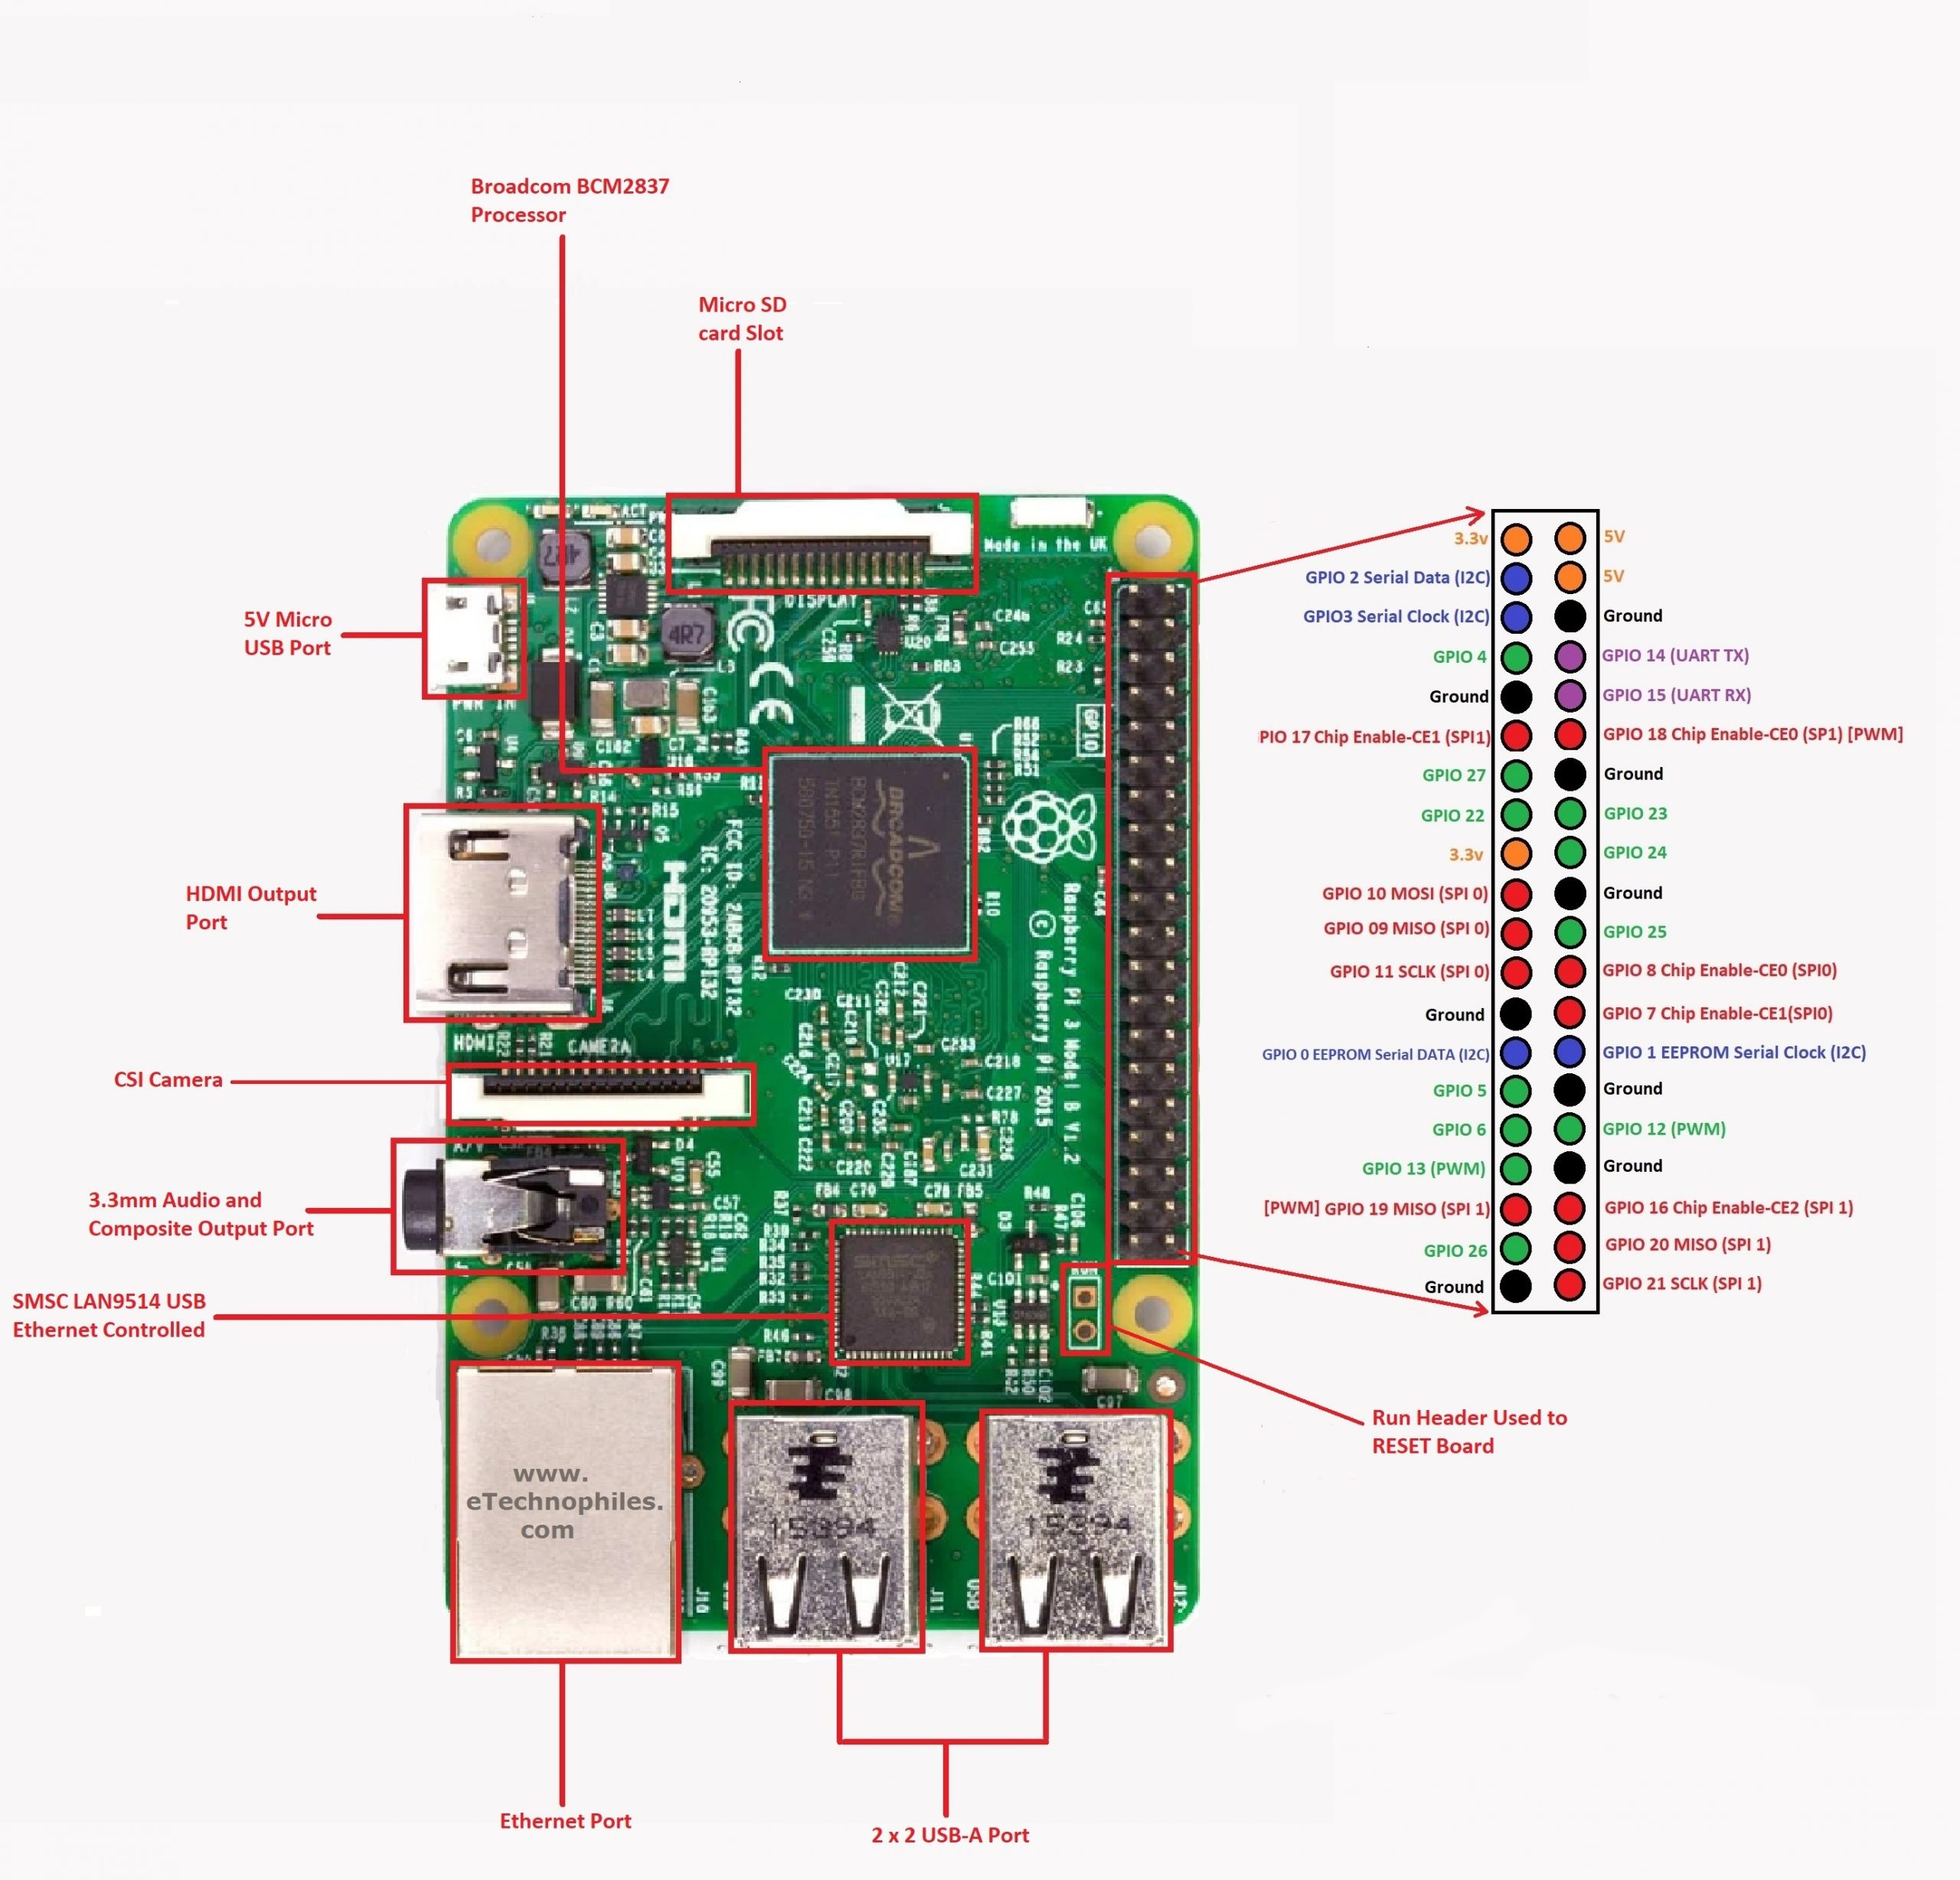
Figure 3.1 Raspberry pi 3 model B board
Raspberry Pi is a small, powerful, cheap, hackable and education-oriented computer board introduced in 2012 . It operates in the same way as a standard PC, requiring a keyboard for command entry, a display unit and a power supply. This credit card-sized computer with many performances and affordable for 25-35$ is perfect platform for interfacing with many devices. The vast majority of the system’s components – its central and graphics processing units, audio and communications hardware along with 256 MB (Model A) – 512 MB (Model B) memory chip, are built onto single component. The Raspberry Pi board contains essential (processor, graphics chip, program memory - RAM) and other optional devices (various interfaces and connectors for peripherals). The processor of Raspberry Pi is a 32 bit, 700 MHz System on a Chip, which is built on the ARM11 architecture and can be overclocked for more power [4]. SD
Flash memory serves as a hard drive to Raspberry Pi’s processor. The unit is powered via the micro USB connector while internet connectivity may be via an Ethernet/LAN cable or via anUSB dongle (WiFi connectivity) The Raspberry Pi, like any other computer, uses an operating system. The Linux option called Raspbian is a great match for Raspberry Pi because it’s free and open source, keeping the price of the platform low, and making it more hackable. There are also a few non-Linux OS options available.
Raspberry Pi 3 model 3 specs
- Quad Core 1.2GHz Broadcom BCM2837 64bit CPU
- 1GB RAM
- BCM43438 wireless LAN and Bluetooth Low Energy (BLE) on board
- 100 Base Ethernet
- 40-pin extended GPIO
- 4 USB 2 ports
- 4 Pole stereo output and composite video port
- Full size HDMI
- CSI camera port for connecting a Raspberry Pi camera
- DSI display port for connecting a Raspberry Pi touchscreen display
- Micro SD port for loading your operating system and storing data
- Upgraded switched Micro USB power source up to 2.5A

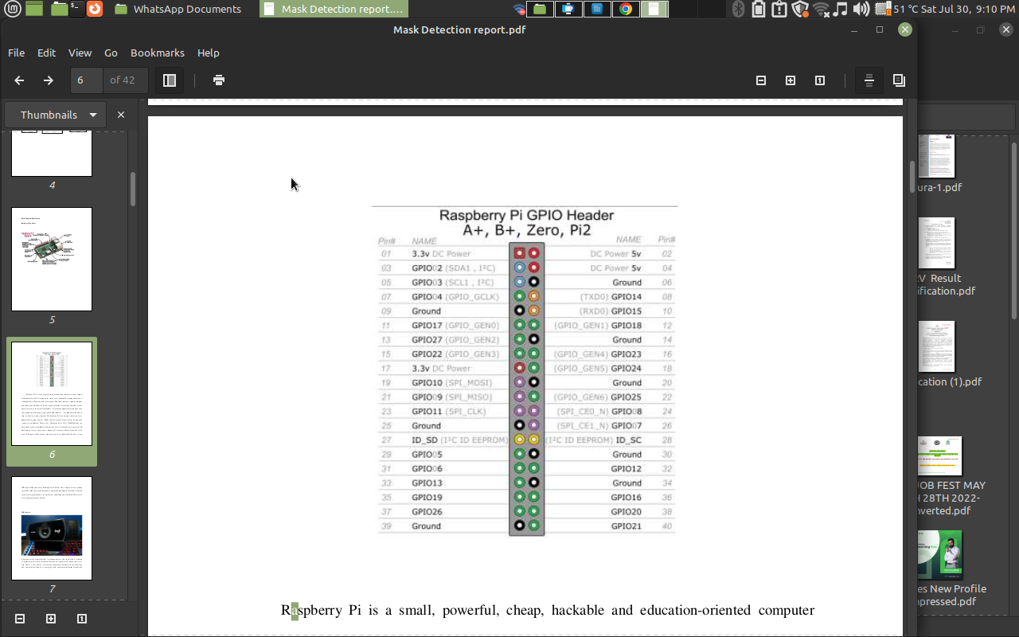

3.2 USB Camera
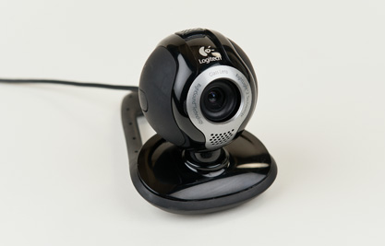

Figure 3.2 USB camera
A webcam is a video camera that feeds or streams an image or video in real time to or through a computer network, such as the Internet. Webcams are typically small cameras that sit on a desk, attach to a user's monitor, or are built into the hardware. Webcams can be used during a video chat session involving two or more people, with conversations that include live audio andvideo. Webcam software enables users to record a video or stream the video on the Internet. As video streaming over the Internet requires much bandwidth, such streams usually use compressed formats. The maximum resolution of a webcam is also lower than most handheld video cameras, as higher resolutions would be reduced during transmission. The lower resolution enables webcams to be relatively inexpensive compared to most video cameras, but the effect is adequate for video chat sessions.
3.3 MLX 90614
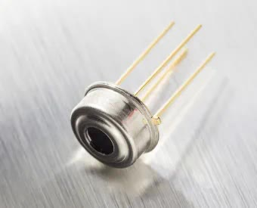Figure MLX 90614

The MLX90614 is an infrared thermometer for non-contact temperature measurements. Both the IR sensitive thermopile detector chip and the signal conditioning ASIC are integrated in the same TO-39 can. Integrated into the MLX90614 are a low noise amplifier, 17-bit ADC and powerful DSP unit thus achieving high accuracy and resolution of the thermometer ,The thermometer comes factory calibrated with a digital SMBus output giving full access to the measured temperature in the complete temperature range(s) with a resolution of 0.02°C. , The user can configure the digital output to be pulse width modulation (PWM). As a standard, the 10-bit PWM is configured to continuously transmit the measured temperature in range of -20 to 120°C, with an output resolution of 0.14°C.
MLX 90614 Specifications
Small size and low cost
- Easy to integrate
- Factory calibrated in wide temperature range: -40 to 125°C for sensor temperature and -70 to 380°C for object temperature
- High accuracy of 0.5°C over wide temperature range (0..+50 C for both Ta and To)
- Medical accuracy of 0.1°C in a limited temperature range available on request
- Measurement resolution of 0.02°C
- Single and dual zone versions
- SMBus compatible digital interface for fast temperature readings and building sensor networks
- Customizable PWM output for continuous reading
- Available in 3V and 5V versions
- Simple adaptation for 8 to 16V applications
- Power saving mode
- Different package options for applications and measurements versatility
- Automotive grade
3.4 POWER SUPPLY
Power is the backbone of any electronic system and the power supply is what feeds the system. Choosing the right supply can be the critical difference between a device working at optimum levels and one that may deliver inconsistent results. The power supply unit is the part of the hardware that is used to convert the power provided from the outlet into usable power to many parts inside an electrical device. Every energy supply must drive its load, which is connected to it. Depending on its design, a power supply unit may obtain energy from various types of energy sources, like electrical energy transmission systems, electromechanical systems such as generators and alternators, solar power converters, energy storage devices such as a battery and fuel cells, or other power supply. There are two types of power supplies existed, AC and DC power supply. Based on the electrical device’s electric specifications it may use AC power or DC power.
3.4.1 MLX
MLX operates at 3V or 5V
3.4.1 Power Supply Block Diagram
The Power supply circuit is used in various electrical & electronic devices. The power supply circuits are classified into different types based on the power they utilize for providing for circuits or devices. For instance, the microcontroller based circuits are generally the 5V DC regulated power supply (RPS) circuits, which can be designed with the help of different method for changing the power from 230V AC to 5V DC.The power supply block diagram, and the step by step conversion of 230V AC to 12V

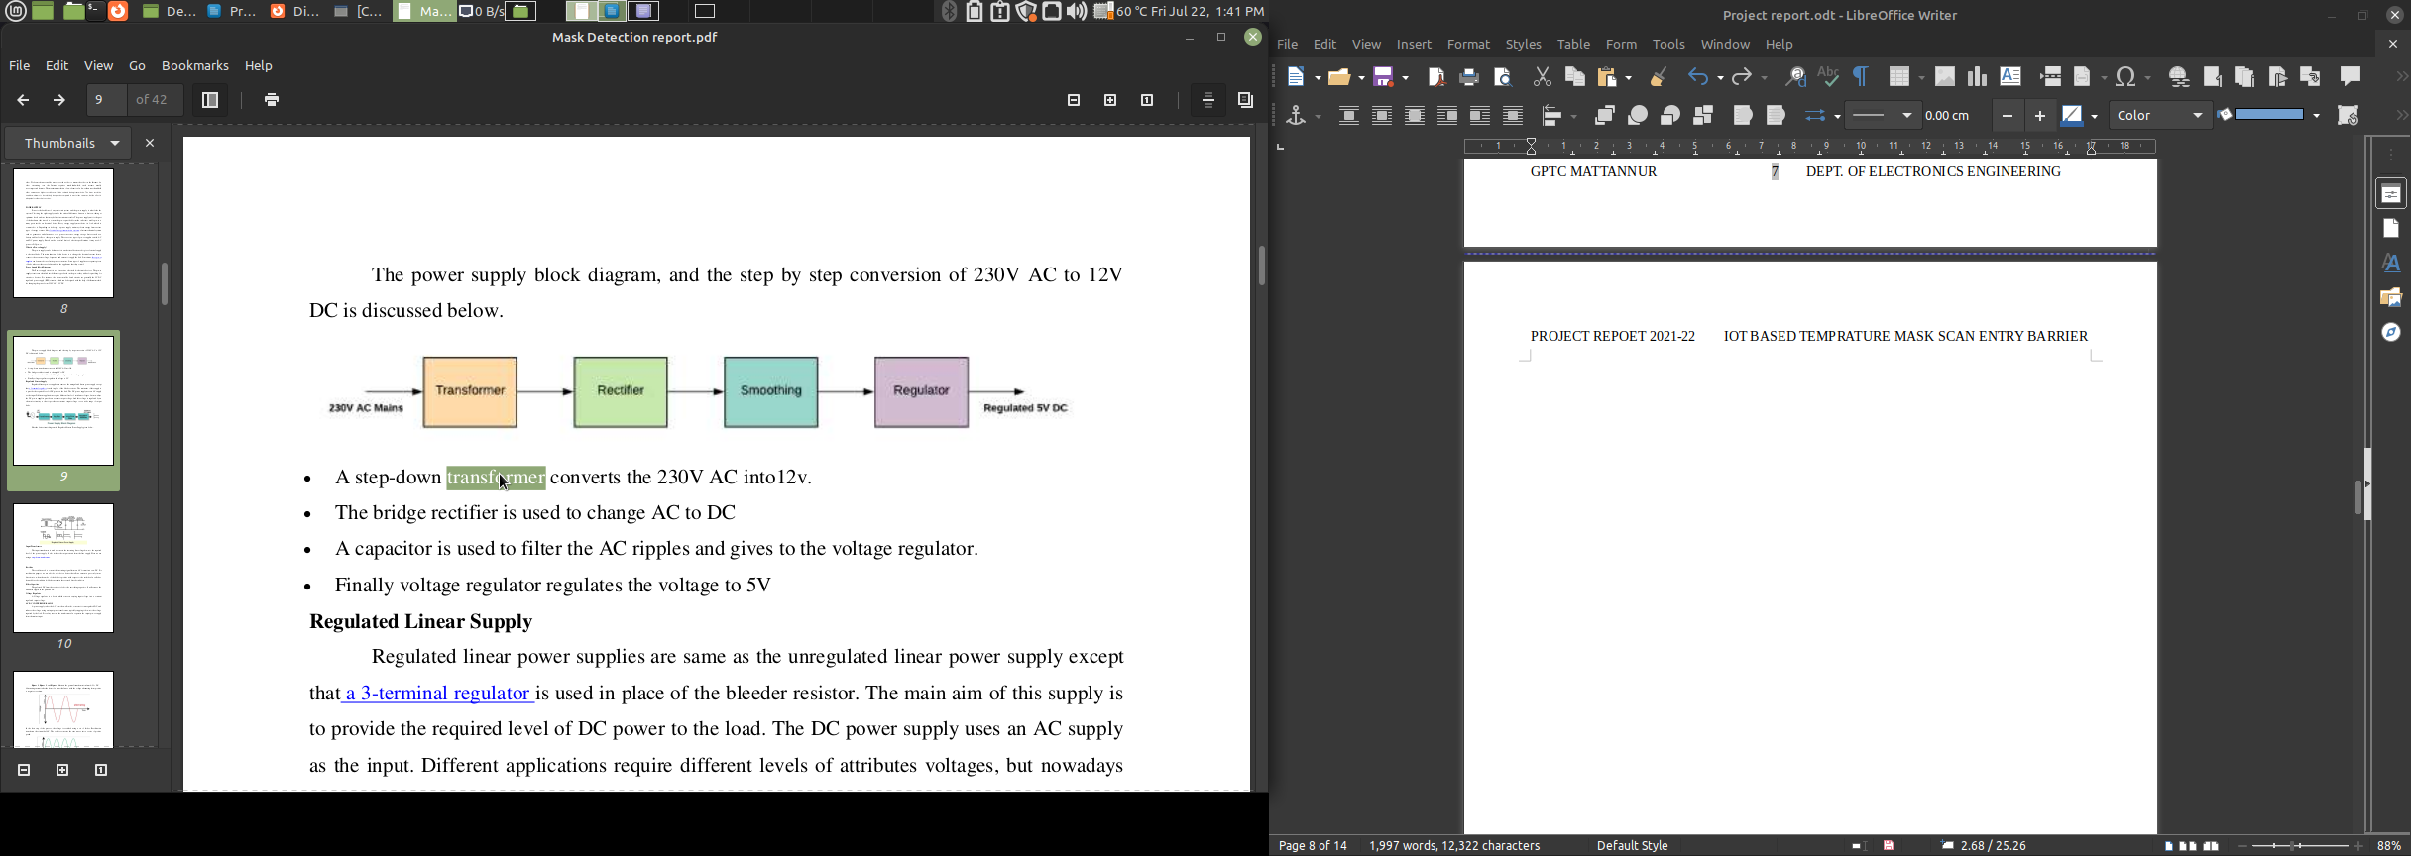
• A step-down transformer converts the 230V AC into12v.
• The bridge rectifier is used to change AC to DC
• A capacitor is used to filter the AC ripples and gives to the voltage regulator.
• Finally voltage regulator regulates the voltage to 5V

CHAPTER 3
HARDWARE DESCRIPTION
3.1 Introduction To Image Processing
Image processing is the process of transforming an image into a digital form and performing certain operations to get some useful information from it. The image processing system usually treats all images as 2D signals when applying certain predetermined signal processing methods.
There are five main types of image processing:
- Visualization - Find objects that are not visible in the image
- Recognition - Distinguish or detect objects in the image
- Sharpening and restoration - Create an enhanced image from the original image
- Pattern recognition - Measure the various patterns around the objects in the image
- Retrieval - Browse and search images from a large database of digital images that are similar to the original image
3.2 Real-time Face recognition python project with OpenCV
Face Recognition is a technology in computer vision. In Face recognition / detection we locate and visualize the human faces in any digital image.
It is a subdomain of Object Detection, where we try to observe the instance of semantic objects. These objects are of particular class such as animals, cars, humans, etc. Face Detection technology has importance in many fields like marketing and security.

Cascade Classifiers and Haar Features
Cascade Classifiers and Haar Features are the methods used for Object Detection. It is a machine learning algorithm where we train a cascade function with tons of images. These images are in two categories: positive images containing the target object and negative images not containing the target object.
There are different types of cascade classifiers according to different target objects. In our project, we will use a classifier that considers the human face to recognize it as the target object.
Haar Feature selection technique has a target to extract human face features. Haar features are like convolution kernels. These features are different permutations of black and white rectangles. In each feature calculation, we find the sum of pixels under white and black rectangles

Haar-cascade Detection in OpenCV
OpenCV provides pre-trained models on Haar features and Cascade classifiers. These models are located in OpenCV installation. You can find the necessary XML files at “/home/<username>/.local/lib/<python-version>/site-packages/cv2/data/”

Steps to implement human face recognition with Python & OpenCV
1. Imports:
import cv2
import os
2. Initialize the classifier:
cascPath=os.path.dirname(cv2.__file__)+"/data/haarcascade_frontalface_default.xml"
faceCascade = cv2.CascadeClassifier(cascPath)
3. Apply faceCascade on webcam frames:
video_capture = cv2.VideoCapture(0)
while True:
# Capture frame-by-frame
ret, frames = video_capture.read()
gray = cv2.cvtColor(frames, cv2.COLOR_BGR2GRAY)
faces = faceCascade.detectMultiScale(
gray,
scaleFactor=1.1,
minNeighbors=5,
minSize=(30, 30),
flags=cv2.CASCADE_SCALE_IMAGE
)
# Draw a rectangle around the faces
for (x, y, w, h) in faces:
cv2.rectangle(frames, (x, y), (x+w, y+h), (0, 255, 0), 2)
# Display the resulting frame
cv2.imshow('Video', frames)
if cv2.waitKey(1) & 0xFF == ord('q'):
break
4. Release the capture frames:
video_capture.release()
cv2.destroyAllWindows()
5. Now, run the project file using:
python3 face_detection.py

CHAPTER 4

SOFTWARE DESCRIPTION

4.1 Python IDLE
An integrated development environment is a software application that provides comprehensive facilities to computer programmers for software development And Python IDE is software application dedicated IDE for python and IDLE is Python’s Integrated Development and Learning Environment.
IDLE has the following features:
- coded in 100% pure Python, using the tkinter GUI toolkit
- cross-platform: works mostly the same on Windows, Unix, and macOS
- Python shell window (interactive interpreter) with colorizing of code input, output, and error messages
- multi-window text editor with multiple undo, Python colorizing, smart indent, call tips, auto completion, and other features
- search within any window, replace within editor windows, and search through multiple files (grep)
- debugger with persistent breakpoints, stepping, and viewing of global and local namespaces
- configuration, browsers, and other dialogs

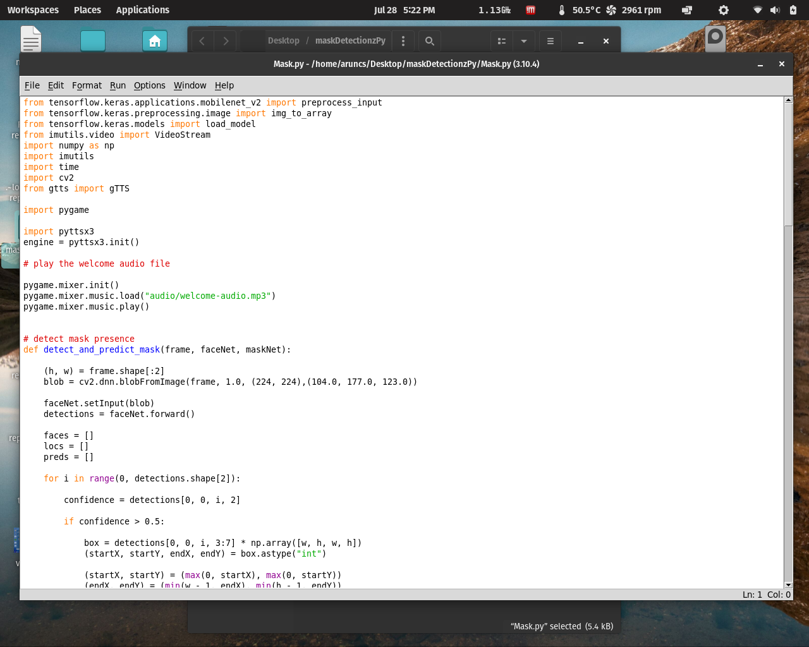
Fig: Python IDLE Main Window

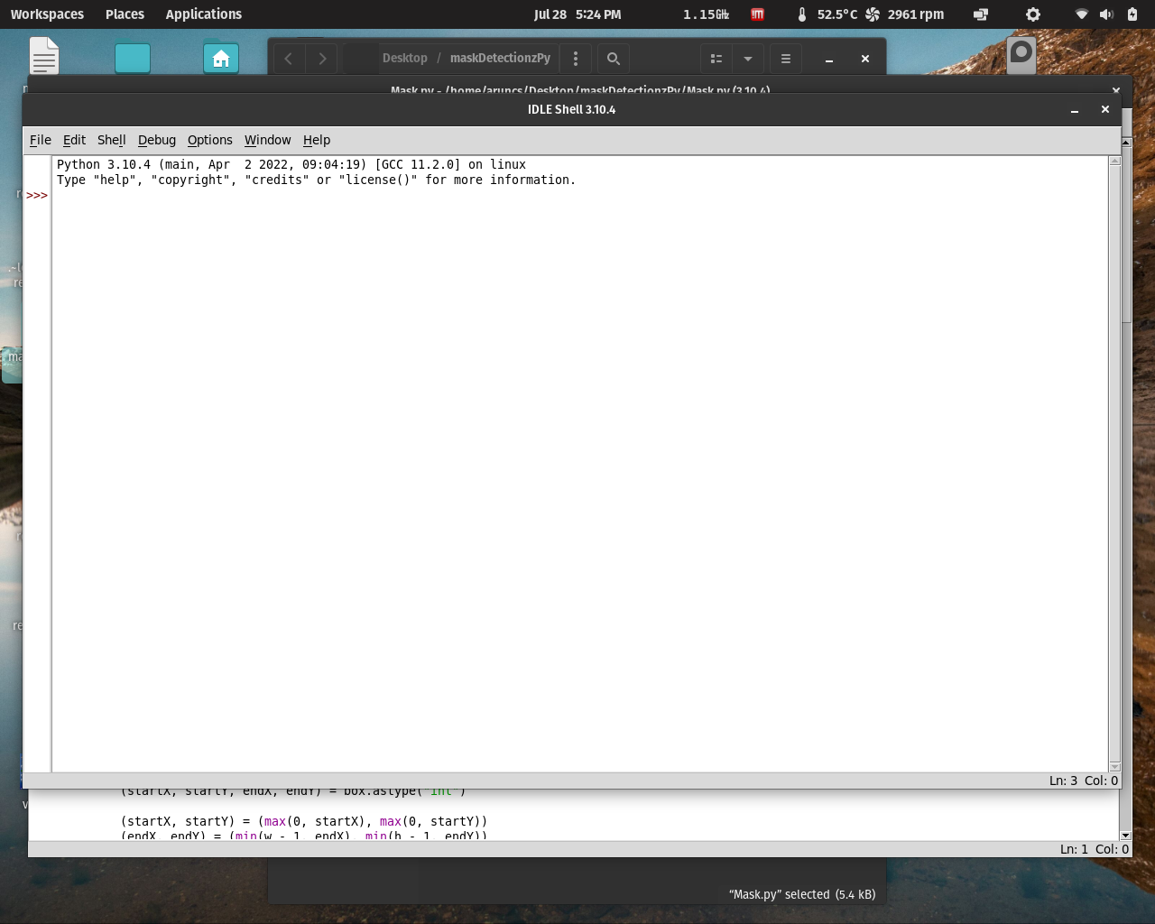
Fig: Python IDLE run window

4.2 VNC viewer
VNC Viewer is used for local computers and mobile devices you want to control from. A device such as a computer, tablet, or smart phone with VNC Viewer software installed can access and take control of a computer in another location.
It is a graphical desktop sharing system that allows a user to remotely control the desktop of a remote computer (running VNC Server) from your device, and it transmits the keyboard and mouse or touch events to VNC Server, so that once you are connected, you have control over the computer you’ve accessed. If you’re using your mobile phone, for example, you would be able to use the computer you’ve remotely accessed as though you were sitting right in front of it.

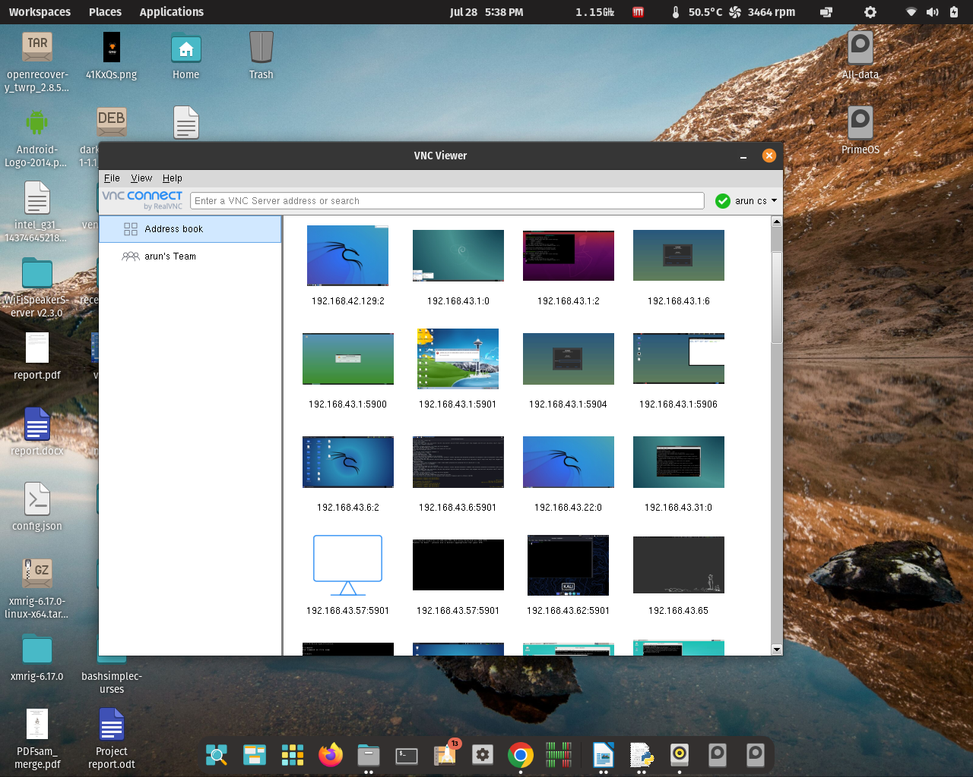
Figure 4.2 Real VNC Viewer Main Window

CHAPTER X

MONITORING
VNC
VNC stands for Virtual Network Computing. It is a cross-platform screen sharing system that was created to remotely control another computer. In computing, Virtual Network Computing (VNC) is a graphical desktop-sharing system that uses the Remote Frame Buffer protocol (RFB) to remotely control another computer. It transmits the keyboard and mouse input from one computer to another, relaying the graphical-screen updates, over a network.[1]
VNC is platform-independent – there are clients and servers for many GUI-based operating systems and for Java. Multiple clients may connect to a VNC server at the same time. Popular uses for this technology include remote technical support and accessing files on one's work computer from one's home computer, or vice versa.
VNC was originally developed at the Olivetti & Oracle Research Lab in Cambridge, United Kingdom. The original VNC source code and many modern derivatives are open source under the GNU General Public License.
HDMI

CHAPTER 6

FLOW CHART

Start

Load Face Detection model and mask detection model

Capture a Frame
1

Detect and predict mask detection value

If mask value < without mask value
1

Scan the temprature

If temprature <
high temprature

Open the Gate

1
CHAPTER 8

COST ESTIMATION

Sl.  No. | ITEMS | QUANTITY | COST
1 | Raspberry Pie | 1 | 600
2 | Stepper Motor | 1 | 180
3 | USB Webcam | 1 | 400
4 | MLX 90614 | 1 | 330
5 | Power Supply 12v | 4 | 160
6 |  | 1 | 50
7 | Power supply | 1 | 560
8 | IC 7805 | 1 | 20
9 | App design cost | 1 | 8000
 | TOTAL COST |  | 10300



